Experiment _ 5

AIM

Design PDA for input aabbbbc (a^nb^2n)

PROCEDURE

1. Start the automata
2. Enter the states
3. Connect the respective nodes (states) and self loop.
4. Enter the inputs values in the named nodes .
5. Compile the execution with suitable inputs
6. Stop the executions.

Design input:

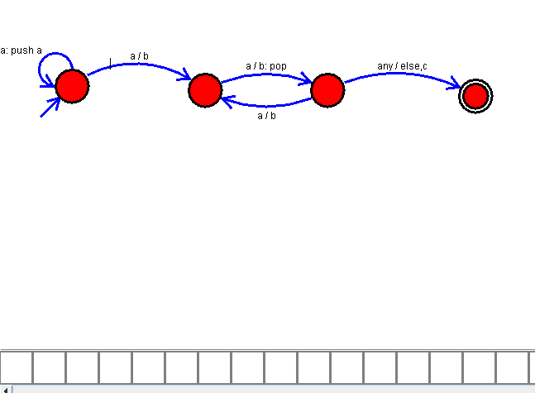

OUTPUT:

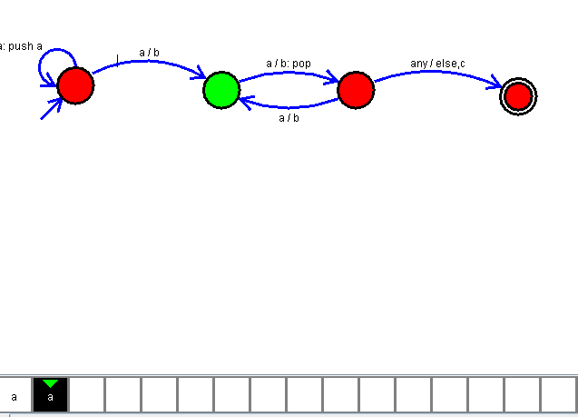

RESULT

Thus the design of PDA for the given input as been executed successfully.